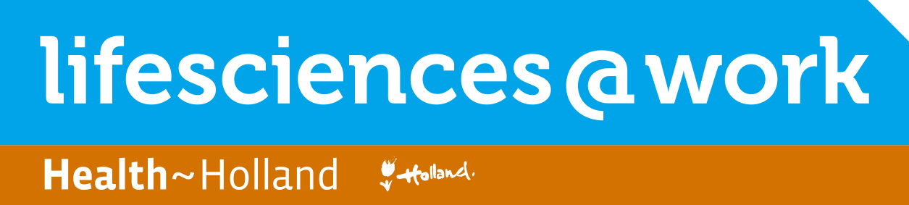

Venture Challenge Fall 2017
Venture Proposal Form

Please complete and submit this form to: Venturechallenge@health-holland.com

Submission deadline: 4 September 2017

Name and contact details main applicant:
- Name:
- Organisation:
- Department:
- Phone: +
- E-mail:

Name and contact details other team members:
- Name:
- Organisation:
- Department:
- Phone:
- E-mail:

- Name:
- Organisation
- Department:
- Phone:
- E-mail:

Venture Name:
Working name or one line description of the scientific finding you want to commercialize
……………………………………………………………………………………………………………………………………………………………………………………
……………………………………………………………………………………………………………………………………………………………………………………
……………………………………………………………………………………………………………………………………………………………………………………

Relation to a University or Knowledge Institute:
Is your proposal originating from or related to a University or Knowledge Institute? If yes, which University/Institute?
……………………………………………………………………………………………………………………………………………………………………………………
……………………………………………………………………………………………………………………………………………………………………………………
……………………………………………………………………………………………………………………………………………………………………………………

What’s your venture about?
What is the underlying science/technology and how is this protected (patented)?
Can it be commercially offered as a new product or as a new service?
Is it a new technology that would improve performance or reduce costs of an existing process?
Or is it a new process that enables activities that could not be done before?
Don’t dwell on technical details, but explain clearly who you see as customers that would benefit from your product/service and what difference it would make to them? (maximum 30 lines)
……………………………………………………………………………………………………………………………………………………………………………………
……………………………………………………………………………………………………………………………………………………………………………………
……………………………………………………………………………………………………………………………………………………………………………………

How big is your market?
Please provide a rough estimate of the market for your product/service.

For example, if your idea is about a new product/service, how many customers (i.e. businesses or consumers) might want it, how much would they be willing to spend on it, and what percentage would be spent with your Venture? Don’t worry if you do not have all the numbers: that’s normal at this stage.
Or, if your idea is about cost savings, how much time, money or resources would your technology/process save your customers?
……………………………………………………………………………………………………………………………………………………………………………………
……………………………………………………………………………………………………………………………………………………………………………………
……………………………………………………………………………………………………………………………………………………………………………………

Is your product/service unique?
Coming up with a unique product/service is often the key to commercial success. Offering the same as your competitors will not give you the best financial return.

Describe here how your offering differs from other products/services currently on the market (e.g., does it address an unfulfilled customer need?) or processes/technologies currently used by competitors (e.g., is it faster?).
……………………………………………………………………………………………………………………………………………………………………………………
……………………………………………………………………………………………………………………………………………………………………………………

Why you?
Tell us why you think your team and your organization is the right entity to take this idea forward successfully.

Think about skills, know-how, patents, assets, relationships, customer bases, etc. Would these give your venture an advantage over competitors? Also think about what you’re missing to become successful.
……………………………………………………………………………………………………………………………………………………………………………………
……………………………………………………………………………………………………………………………………………………………………………………
……………………………………………………………………………………………………………………………………………………………………………………

Please note that your team consists of min. 3 persons and are all available at the following dates:
Interviews 12 and 13 September
Workshop I 2 – 4 October 2017
Workshop II 1 – 3 November 2017
Finals 17 November 2017 (to be confirmed)
Announcement of the winner 22 November 2017, Dutch Life Sciences Conference

Availability intake interview
If your Venture Proposal looks promising, your team will be invited for an intake interview.
The one hour interviews will take place on Tuesday 12 September or Wednesday 13 September 2017. Please indicate your availability below.

Date | Time | Yes | No
Tuesday 12 Sept | 9:00
Tuesday 12 Sept | 10.00
Tuesday 12 Sept | 11:00
Tuesday 12 Sept | 13:00
Tuesday 12 Sept | 14:00
Tuesday 12 Sept | 15.00
Tuesday 12 Sept | 16.00
Tuesday 12 Sept | 17.00
Wednesday 13 Sept | 9:00
Wednesday 13 Sept | 10:00
Wednesday 13 Sept | 11.00
Wednesday 13 Sept | 13.00
Wednesday 13 Sept | 14.00
Wednesday 13 Sept | 15.00
Wednesday 13 Sept | 16:00
Wednesday 13 Sept | 17:00

The LS@W Venture Challenge is part of the LifeSciences@Work Accelerator:
the national Accelerator for high potential startup initiatives.

- We help scientists build their business!

www.lifesciencesatwork.nl

- Follow us on Twitter: @LSatW
- Join us on LinkedIn: Lifescience@Work Accelerator Group

Contact
- Chretien Herben | Programme Director
- E-mail: herben@lifesciencesatwork.nl
- Phone: +31 (0) 6 149 10145

Powered by

