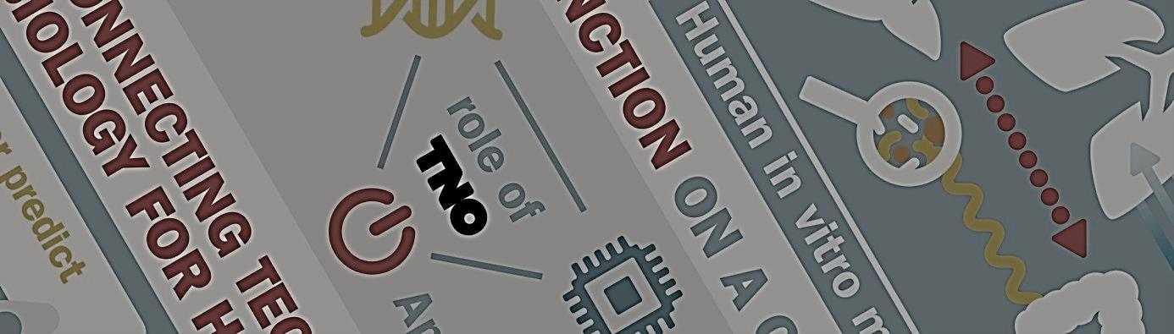
The 3 Dimensions
of
Organ-on-a-Chip

31 October 2016
10.00 – 17.00

Symposium registration form
Location: Beatrix Building, Jaarbeursplein 6a,
3521 AL Utrecht

Please complete this form and return it to:
monique.brewster@tno.nl

Name:....................................................................................

Company:..............................................................................

Street:....................................................................................

Postcode & city...................................................................

Country:.................................................................................

Telephone:.............................................................................

Email:.....................................................................................

See for the program the enclosed flyer

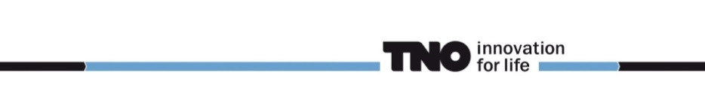
The 3 Dimensions of
Organ-on-a-Chip

Practical information

Meeting location:
Beatrix Building, Jaarbeursplein 6a,
3521 AL Utrecht

Route

Train
Jaarbeurs/Beatrix Building is located next to Utrecht Central Station, making it very easy to reach by train. From the Central Station, follow the signs that read ‘Jaarbeursplein’. It is a five-minute walk to the Beatrix Building or the venue of the Jaarbeurs.
Plan your public transport trip here.

Car & Parking
If you are travelling by car, please follow the blue ANWB signs that read ‘Jaarbeurs’ from the Utrecht Ring Road. Jaarbeurs has ample parking space on its own grounds in the centre of Utrecht.

.

